**Solidity**

1. **Write a solidity smart contract to display hello world message.**

**Code:-**

pragma solidity >=0.7.0 <0.9.0;

contract HelloWorld

{

    function getMessage() public view returns(string memory)

    {

        return 'Hello World';

    }

}

**Output:-**

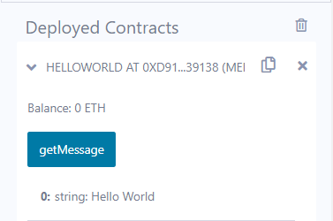

1. **Write a solidity smart contract to demonstrate state variable, local variable and global variable.**

**Code:-**

pragma solidity >=0.7.0 <0.9.0;

contract SolidityTest {

    uint storedData; // State variable

    constructor() public

    {

        storedData = 10;

    }

    function getResult() public view returns(uint){

        uint a = 1;

        uint b = 2;

        uint result = a + b;

        return storedData;

    }

}

**Output:-**

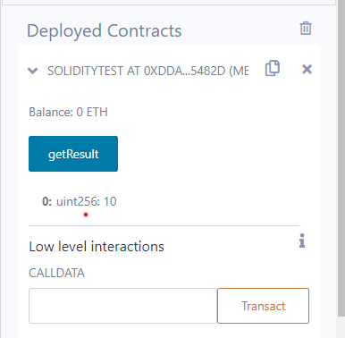

1. **Write a solidity smart contract to demonstrate getter and setter methods.**

**Code:-**

pragma solidity >=0.7.0 <0.9.0;

contract GetAndSet{

    string name;

    string  lname;

 function set(string memory newName, string memory lastname) public {

 name = newName;

 lname = lastname;

 }

 function get() public view returns (string memory, string memory) {

 return (name,lname);

 }

}

**Output:**

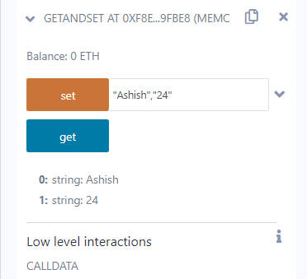

1. **Write a solidity smart contract to demonstrate function modifier.**

**Code:-**

pragma solidity ^0.5.0;

contract Owner

{

address owner;

constructor() public

{

owner = msg.sender;

}

modifier onlyOwner {

require(msg.sender == owner);

_;

}

modifier costs(uint price)

{

if (msg.value >= price)

{

_;

}

}

function getPrice() public view returns(uint price)

{

return price;

}

}

contract Register is Owner {

mapping (address => bool) registeredAddresses;

uint price;

constructor(uint initialPrice) public { price = initialPrice; }

function register() public payable costs(price) {

registeredAddresses[msg.sender] = true;

}

function changePrice(uint _price) public onlyOwner {

price = _price;

}

}

**Output-**

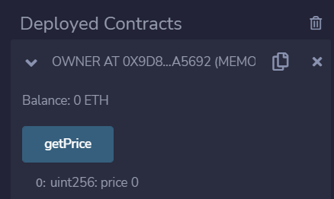

1. **Write a solidity smart contract to demonstrate use of structure.**

**Code-**

pragma solidity ^0.5.0;

contract test {

struct Book

{

string title;

string author;

uint book_id;

}

Book book;

function setBook() public

{

book = Book('Learn Java', 'TP', 100012);

}

function getBookId() public view returns (uint) {

return book.book_id;

}

}

**Output:**

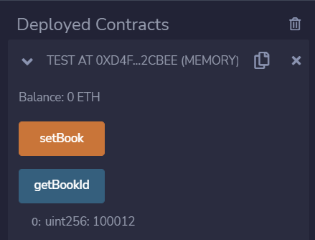

1. **Write a solidity smart contract to calculate percentage of marks obtained by students for six subject in final examination.**

**Code-**

pragma solidity ^0.5.0;

contract percentage{

uint sub_1;uint sub_2; uint sub_3;uint sub_4;uint sub_5;uint sub_6;uint total=600;

uint marksObtained;

function set(uint s1,uint s2 ,uint s3,uint s4,uint s5,uint s6) public {

sub_1=s1;

sub_2=s2;

sub_3=s3;

sub_4=s4;

sub_5=s5;

sub_6=s6;

marksObtained=sub_1+sub_2+sub_3+sub_4+sub_5+sub_6;

marksObtained=marksObtained*100;

}

function getPercentage() public view returns (uint) {

uint percent=marksObtained/total;

return percent;

} }

**Output-**

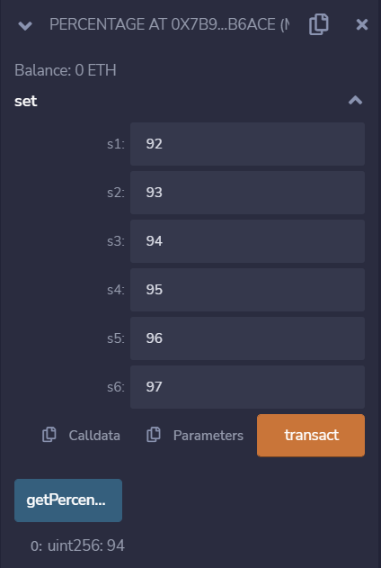

1. **Write a solidity smart contract to find the factorial of entered number.**

**Code:-**

pragma solidity >=0.7.0 <0.9.0;

contract factorial

{

    uint number;

    function set(uint num) public

    {

        number=num;

    }

    function getFactorial() public view returns (uint)

    {

        uint fact=1;

        for(uint i=2;i<=number;i++)

        {

            fact=fact*i;

        }

        return fact;

    } }

**Output:-**

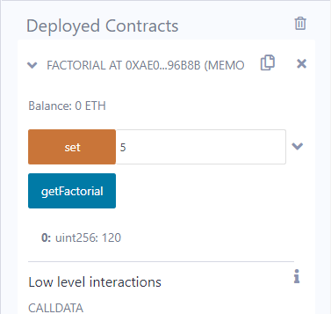

1. **Write a solidity smart contract to check whether entered number is palindrome or not.**

**Code:-**

pragma solidity >=0.7.0 <0.9.0;

contract palindrome{

    uint number;

    function set(uint n) public

    {

        number=n;

    }

    function getPalindrome() public view returns (string memory ) {

        uint rev;

        uint n=number;

        uint reverseNumber=0;

        while(n>0){

            rev=n%10;

            reverseNumber=reverseNumber*10+rev;

            n=n/10;

        }

        if(reverseNumber==number)

            return "number is palindrome";

        else

            return "number is not palindrome";

    }

}

**Output:-**

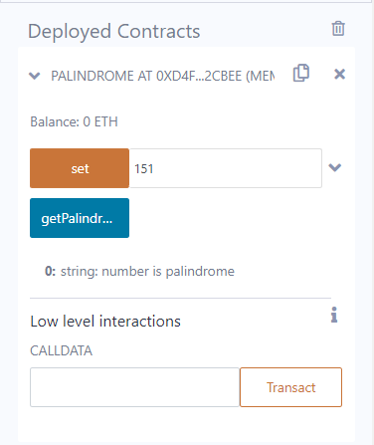 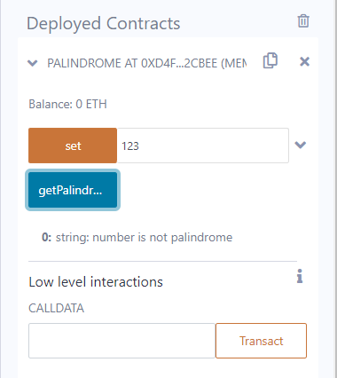

1. **Write a solidity smart contract to generate Fibonacci Series up to given number.**

**Code:-**

pragma solidity >=0.7.0 <0.9.0;

contract fibonacci{

    uint number_of_terms;

    function set (uint n) public {

        number_of_terms=n;

    }

    function getFiboSeries() public view returns (uint[] memory ) {

        uint a=0;

        uint b=1;

        uint c;

        uint[] memory result=new uint[](number_of_terms);

        result[0]=a;

        result[1]=b;

        for(uint i=2;i<number_of_terms;i++){

            c=a+b;

            result[i]=c;

            a=b;

            b=c;

        }

        return result;

    } }

**Output:-**

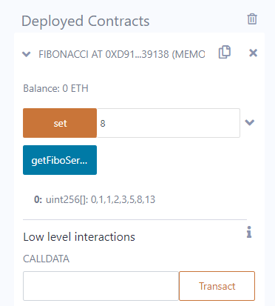

1. **Write a solidity smart contract to check whether entered number is prime number or not.**

**Code:-**

pragma solidity >=0.7.0 <0.9.0;

contract prime{

    function isPrime(uint n) public view returns (string memory )

    {

        string memory message="";

        if(n==0){

            return "Invalid input.";

        }

        else if (n==1){

            return "1 is neither prime nor composite.";

        }

        else if(n==2){

            return "Entered Number is prime.";

        }

        else{

            bool flag=true;

            for(uint i=2;i<=n/2;i++ )

            {

                if(n%i==0)

                {

                    flag=false;

                    break;

                }

            }

            if(flag)

                return "Entered Number is prime.";

            else

                return "Entered Number is not prime.";

        }

    }

}

**Output:-**

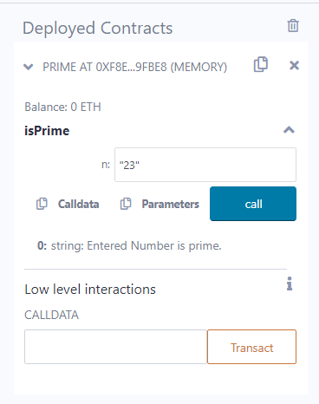 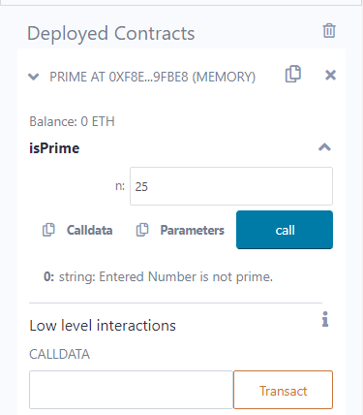

1. **Write a solidity smart contract to create arithmetic calculator which includes functions for operations addition, subtraction, multiplication, division etc.**

**Code:**

pragma solidity >=0.7.0 <0.9.0;

contract arithmetic_calci

{

 function add(uint n1,uint n2) public view returns (uint result )

 {

     return n1+n2;

 }

 function sub(uint n1,uint n2) public view returns (uint result )

 {

    return n1-n2;

 }

 function mul(uint n1,uint n2) public view returns (uint result )

 {

    return n1*n2;

 }

 function div(uint n1,uint n2) public view returns (uint result )

 {

     return n1/n2;

 }

}

**Output:-**

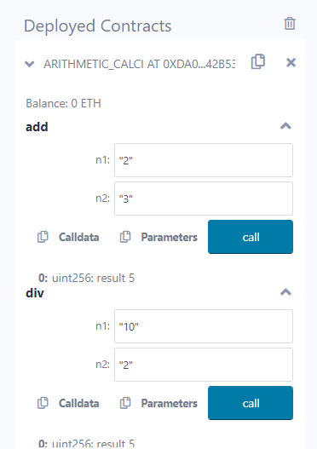 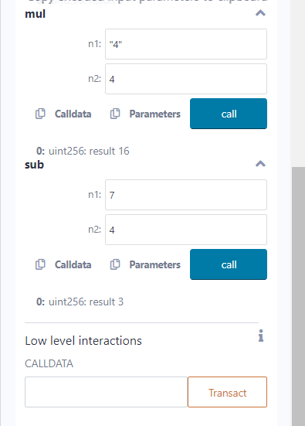

1. **Write a solidity smart contract to demonstrate view function and pure function.**

**Code:-**

pragma solidity >=0.7.0 <0.9.0;

contract pure_and_view {

    function view_demo() public view returns(uint product, uint sum)

    {

        uint a = 1; uint b = 2; // local variable

        product = a * b;

        sum = a + b;

    }

    function pure_demo() public pure returns(uint product, uint sum)

    {

        uint a = 1;

        uint b = 2;

        product = a * b;

        sum = a + b;

    }

}

**Output:-**

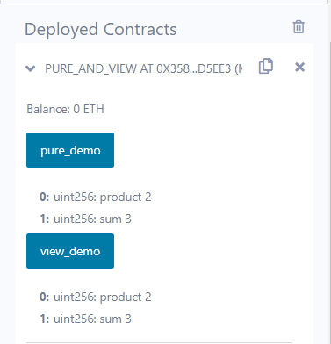

1. **Write a solidity smart contract to demonstrate inbuilt mathematical functions.**

**Code:-**

pragma solidity >=0.7.0 <0.9.0;

contract inBuildFunctions {

    function callAddMod() public pure returns(uint)

    {

      return addmod(4, 5, 3);

    }

   function callMulMod() public pure returns(uint)

   {

      return mulmod(4, 5, 3);

   }

}

**Output:-**

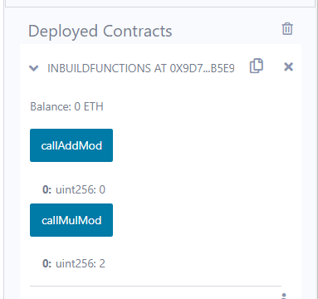

1. **Write a solidity smart contract to demonstrate inheritance in contract.**

**Code:-**

pragma solidity ^0.5.0;

contract C {

//private state variable

uint private data;

//public state variable

uint public info;

//constructor

constructor() public {

info = 10;

}

//private function

function increment(uint a) private pure returns(uint) { return a + 1; }

//public function

function updateData(uint a) public { data = a; }

function getData() public view returns(uint) { return data; }

function compute(uint a, uint b) internal pure returns (uint) { return a + b; }

}

//Derived Contract

contract E is C {

uint private result;

C private c;

constructor() public {

c = new C();

}

function getComputedResult() public {

result = compute(3, 5);

}

function getResult() public view returns(uint) { return result; }

function getData() public view returns(uint) { return c.info(); }

}

**Output-**

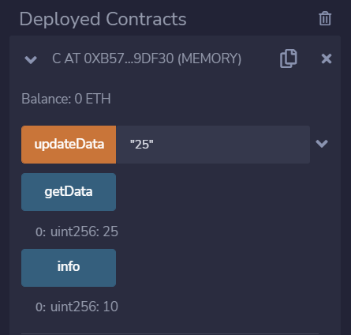

1. **Write a solidity smart contract to demonstrate events.**

**Code:-**

contract eventDemo{

    event Log(address indexed sender, string message);

    event AnotherLog();

    function test() public

    {

        emit Log(msg.sender, "Hello World!");

        emit Log(msg.sender, "Hello EVM!");

        emit AnotherLog();

    } }

**Output:**

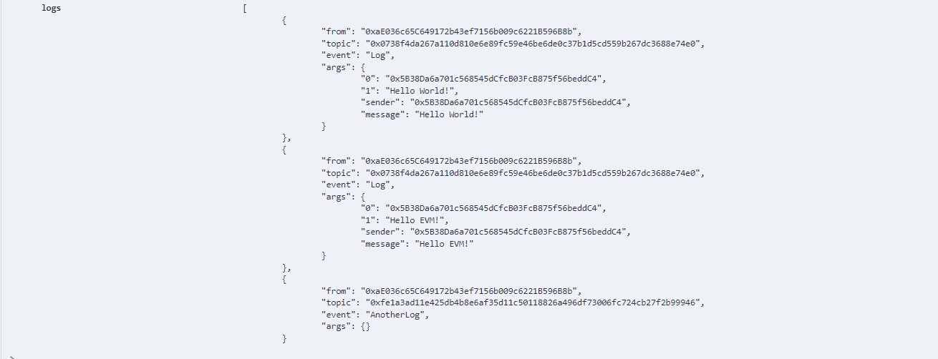

1. **Write a solidity smart contract to demonstrate error handling.**

**Code:-**

pragma solidity 0.5.0;

contract ErroHandling

{

function checkInput(uint _input) public view returns(string memory)

{

require(_input >= 0, "invalid uint8");

require(_input <= 255, "invalid uint8");

return "Input is Uint8";

}

function Odd(uint _input) public view returns(bool)

{

require(_input % 2 != 0);

return true;

} }

**Output:**

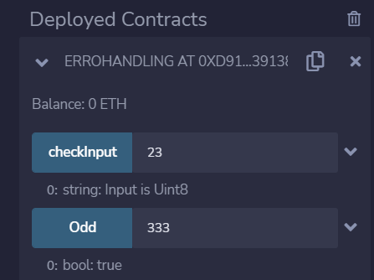

1. **Write a solidity smart contract for Bank Account which provides operations such as check account balance, withdraw amount and deposit amount etc.**

**Code:-**

pragma solidity >=0.7.0 <0.9.0

contract BankApplication {

mapping(address => uint) public userAccount;

mapping(address => bool) public userExists;

function createAcc() public payable returns (string memory) {

require (userExists[msg.sender] == false, 'Account Already Created');

if(msg.value == 0){

userAccount[msg.sender] = 0;

}

userAccount[msg.sender] = msg.value;

userExists[msg.sender] = true;

return 'account created';

}

function deposit() public payable returns (string memory) {

require (userExists[msg.sender] == true, 'Account does not Exist');

require (msg.value > 0, 'Value less than zero') ;

userAccount[msg.sender] += msg.value;

return 'Amount Deposited';

}

function withdraw(uint amount) public payable returns (string memory) {

require (userExists[msg.sender] == true, 'Account does not Exist');

require (userAccount[msg.sender] > amount, 'Insufficient Balance');

require (amount > 0, 'Value less than zero');

userAccount[msg.sender] -= amount;

return 'Withdraw Sucessfull';

}

function TransferAmount(address payable userAddress, uint amount) public payable returns (string memory) {

require(userAccount[msg.sender] > amount, 'Insufficient Balance');

require(userExists[msg.sender] == true, 'Account does not Exist');

require(userExists[userAddress] == true, 'Transfer Account not Available');

require(amount > 0, 'Value less than zero');

userAccount[msg.sender] -= amount;

userAccount[userAddress] += amount;

return 'Transfer Successful';

}

function SendAmount(address payable toAddress, uint256 amount) public payable returns (string memory) {

require(userAccount[msg.sender] > amount, 'Insufficient Balance');

require(userExists[msg.sender] == true, 'Account does not Exist');

require(amount > 0, 'Value less than zero');

userAccount[msg.sender] -= amount;

toAddress.transfer(amount);

return 'Transfer Successful';

}

function userAccountBalance() public view returns (uint){

return userAccount[msg.sender];

}

function accountExist() public view returns (bool){

return userExists[msg.sender];

}

}

**Output:**

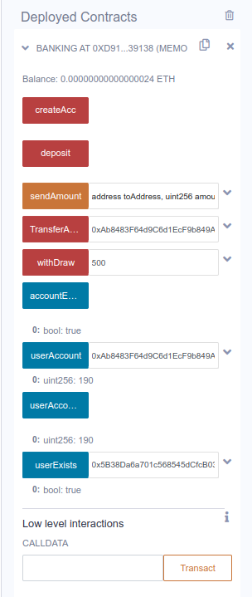

**Account created Successfully:**

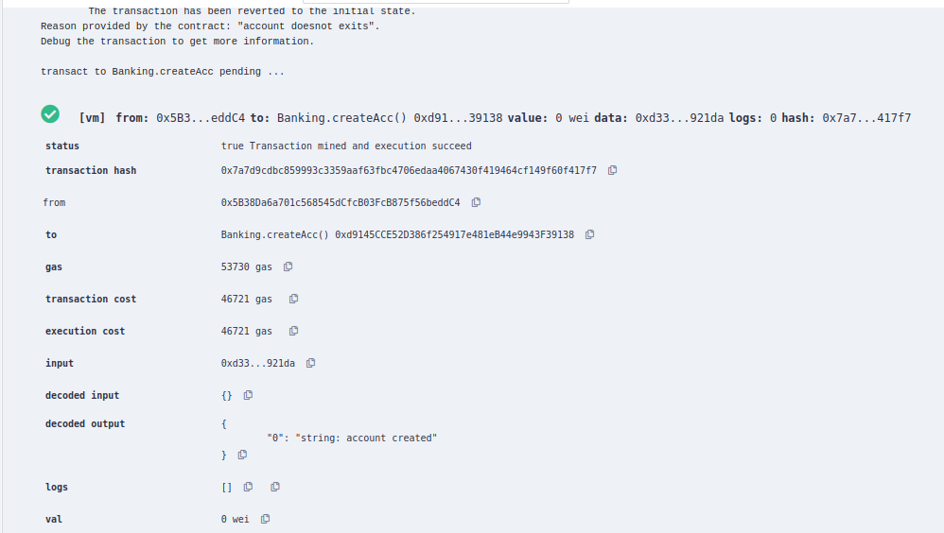

**Account Exist or not:**

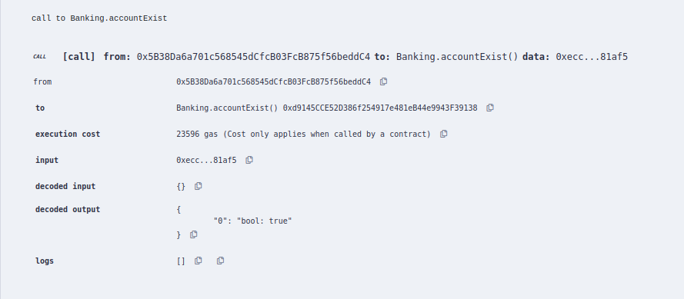

**Depositing amount to our accout (300):**

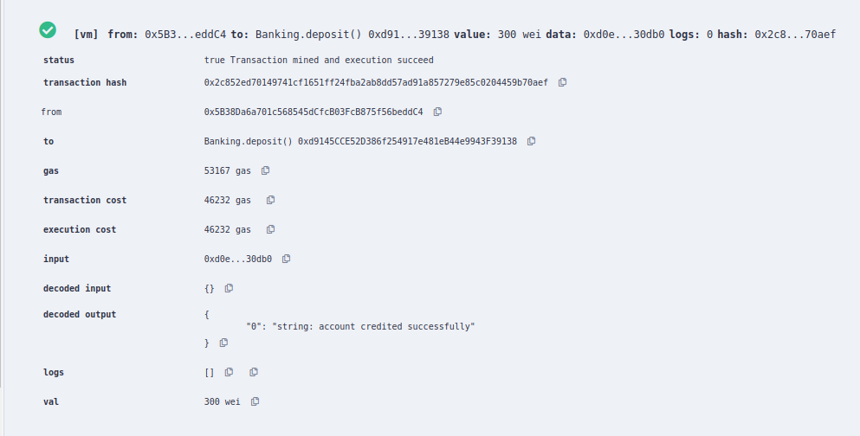

**Checking the account balance:**

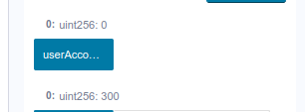

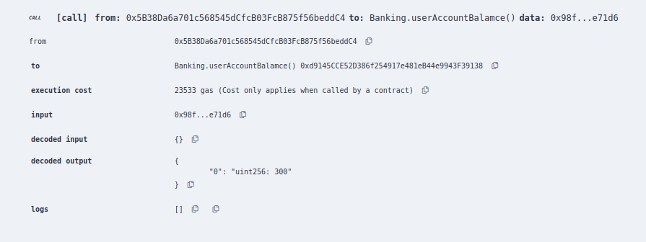

**Withdrawing amount**

**more than our balance**

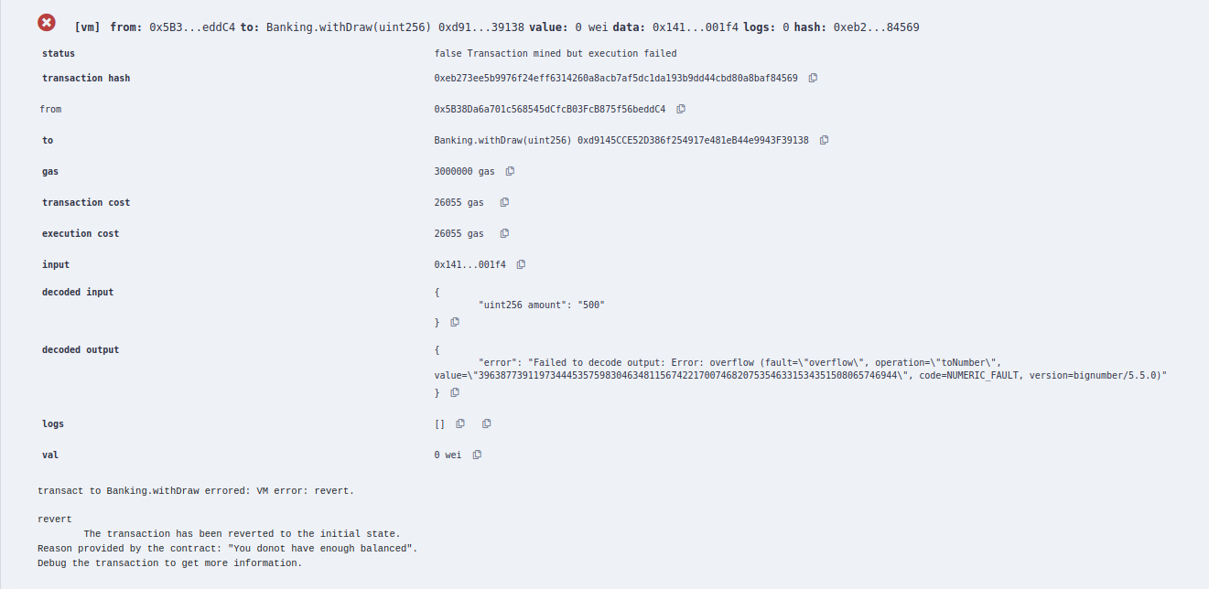

**Less than account balance:-**

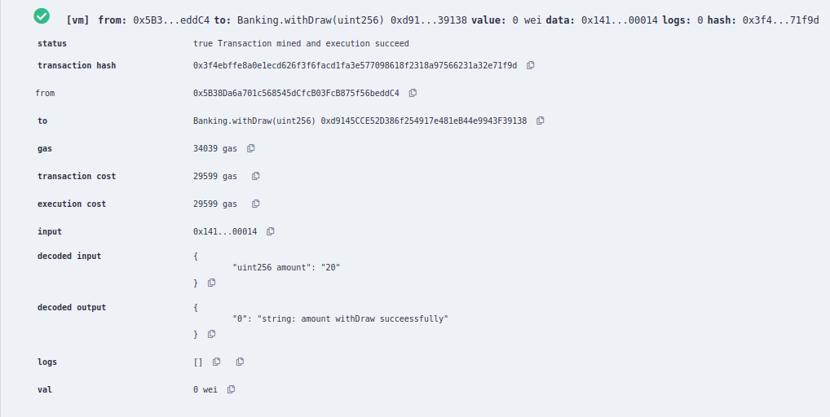

**Amount transfer to another mapping account:-**

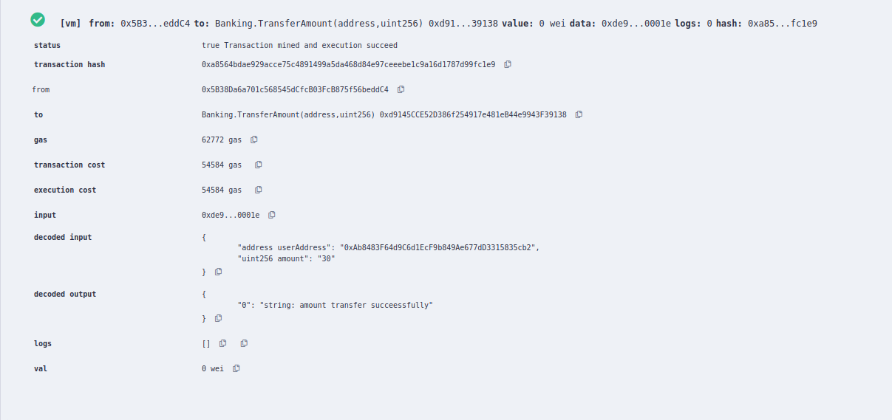

**Amount send to another account:-**

